Task 1 — Create MariaDB Database on EC2

Objective
Install MariaDB server on an EC2 instance and create a database.

What is MariaDB?
MariaDB is an open-source relational database management system (RDBMS).
It stores data in tables.
Example:
Employees

ID Name Salary

1 John 50000
2 David 60000
MariaDB is a fork of MySQL and is fully compatible with it.

Why Install on EC2?
Normally companies first host databases on EC2 because:
- Full OS control
- Easy testing
- Development environment
- Legacy applications
Later they migrate to Amazon RDS for easier management.

Step 1 — Connect to EC2
ssh -i challenge.pem ec2-user@<Public-IP>
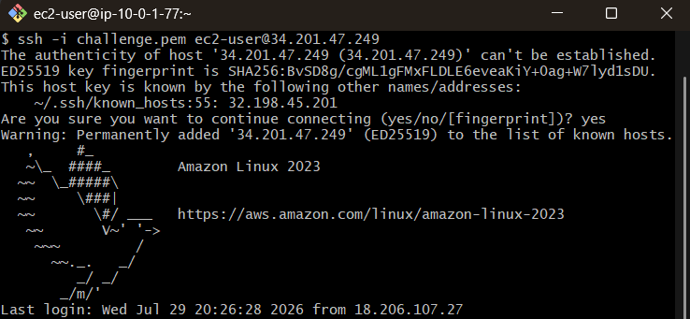

Step 2 — Update Packages
Amazon Linux 2023:
sudo dnf update -y

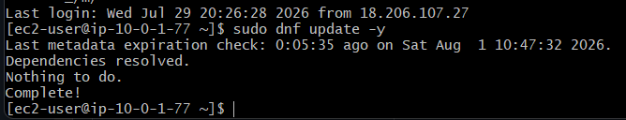

Step 3 — Install MariaDB
Amazon Linux 2023:
sudo dnf install mariadb105-server -y
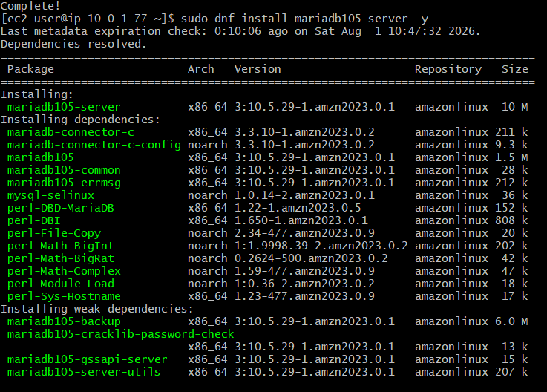

Step 4 — Start Service
sudo systemctl start mariadb

Step 5 — Enable Service
sudo systemctl enable mariadb

Step 6 — Verify Status
sudo systemctl status mariadb
Expected:
active (running)
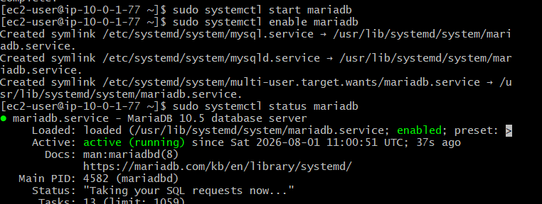

Step 7 — Secure MariaDB
sudo mysql_secure_installation
Typical prompts:
Set root password → Yes

Remove anonymous users → Yes

Disallow remote root login → Yes

Remove test database → Yes

Reload privilege tables → Yes
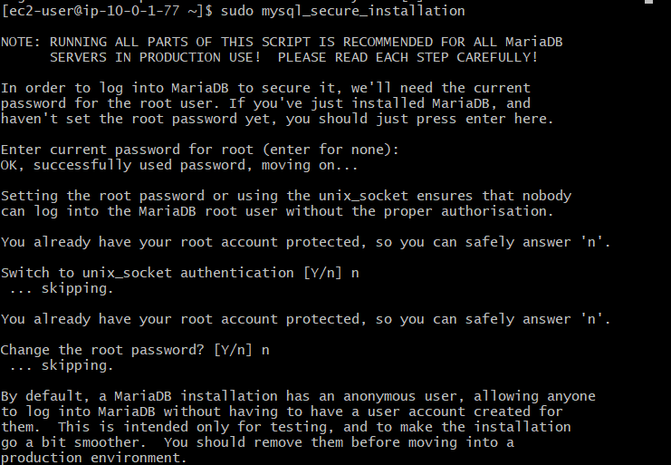
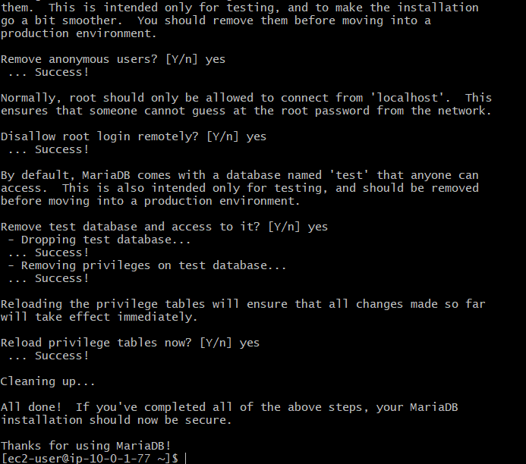

Step 8 — Login to MariaDB
sudo mysql
You should see:
MariaDB [(none)]>
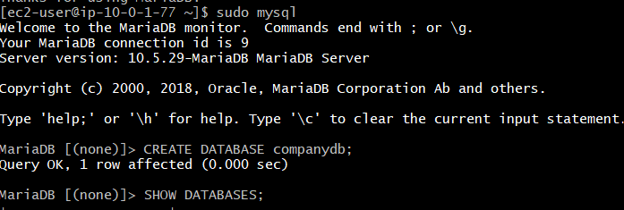

Step 9 — Create Database
CREATE DATABASE companydb;
Verify:
SHOW DATABASES;
Expected:
companydb
information_schema
mysql
performance_schema
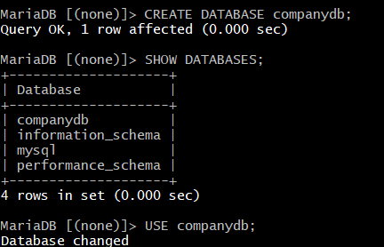

Step 10 — Use Database
USE companydb;
Output:
Database changed
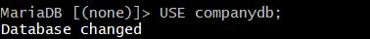

Step 11 — Create Table
CREATE TABLE employees (

id INT PRIMARY KEY,

name VARCHAR(100),

department VARCHAR(50),

salary INT

);
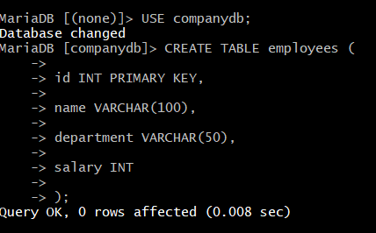
Verify:
SHOW TABLES;
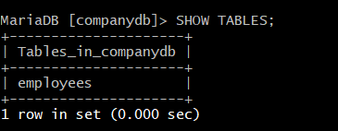

Step 12 — Describe Table
DESCRIBE employees;
Expected:
id

name

department

salary
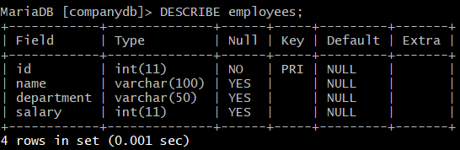

Verification
Show databases: SHOW DATABASES;
Show tables: SHOW TABLES;
Describe table: DESCRIBE employees;
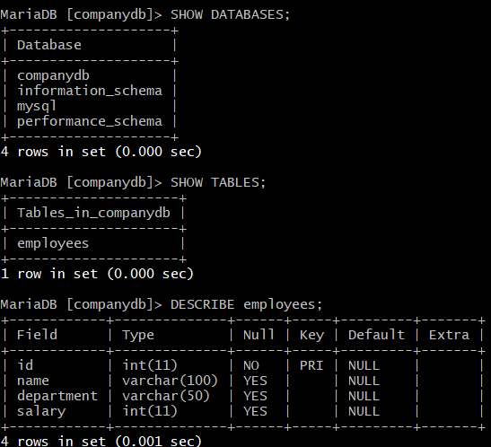

Outcome
You have successfully:
- Installed MariaDB on EC2.
- Started and enabled the MariaDB service.
- Created a database named companydb.
- Created an employees table ready for inserting data.

Task 2: Insert Dummy Data into MariaDB

Objective
Insert sample records into the MariaDB database to simulate real-world application data. This data will be used for backup, migration, restore, and read replica verification in the subsequent tasks.

Prerequisites
- Amazon EC2 instance is running.
- MariaDB Server is installed and running.
- Database (companydb) is created.
- Required table (employees) is created.
- User has access to the MariaDB database.

Outcome
- Sample records inserted into the database successfully.
- Data verified using SQL queries.
- Database is ready for backup and migration to Amazon RDS.

Implementation Steps

Step 1: Connect to the EC2 Instance
ssh -i challenge.pem ec2-user@<EC2-Public-IP>

Step 2: Log in to MariaDB
If using the root user:
sudo mysql
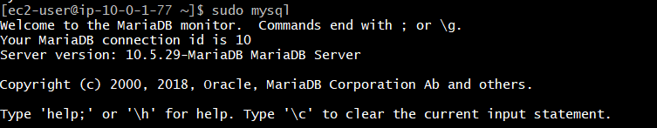

Step 3: Select the Database
USE companydb;
Expected Output:
Database changed
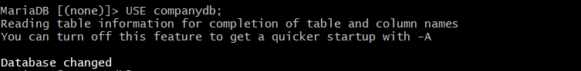

Step 4: Verify the Table
SHOW TABLES;
Expected Output:
+----------------------+
| Tables_in_companydb |
+----------------------+
| employees |
+----------------------+
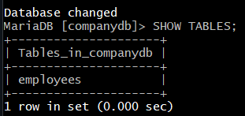

Step 5: Insert Sample Records
INSERT INTO employees (id, name, department, salary)
VALUES
(101, 'John', 'IT', 55000),
(102, 'David', 'HR', 45000),
(103, 'Emma', 'Finance', 60000),
(104, 'Sophia', 'Marketing', 50000),
(105, 'Michael', 'Sales', 52000);
Expected Output:
Query OK, 5 rows affected
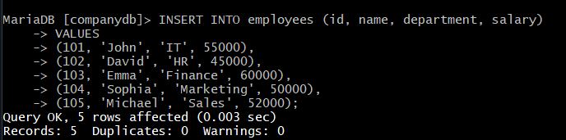

Step 6: Verify the Inserted Data
Display all records:
SELECT * FROM employees;
Expected Output:
+-----+---------+------------+--------+
| id | name | department | salary |
+-----+---------+------------+--------+
| 101 | John | IT | 55000 |
| 102 | David | HR | 45000 |
| 103 | Emma | Finance | 60000 |
| 104 | Sophia | Marketing | 50000 |
| 105 | Michael | Sales | 52000 |
+-----+---------+------------+--------+
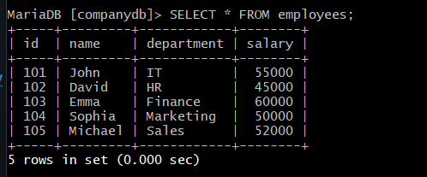

Step 7: Count the Records
SELECT COUNT(*) FROM employees;
Expected Output:
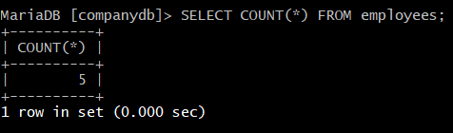

Step 8: Exit MariaDB
EXIT;
or
QUIT;
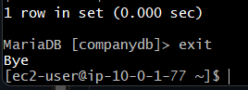

Verification
Verify the following:
- MariaDB login is successful.
- Database companydb exists.
- Table employees exists.
- Five records are inserted successfully.
- SELECT * FROM employees; displays all records.
- SELECT COUNT(*) FROM employees; returns 5.

Real-Time Use Case
Suppose a company has an employee management application. Before migrating the database to Amazon RDS, administrators populate the database with sample or production data. This ensures the migration process transfers both the database structure and the actual records, allowing the application to function correctly after migration.

Outcome
You have successfully:
- Connected to the MariaDB database.
- Selected the companydb database.
- Inserted sample employee records into the employees table.
- Verified the inserted data using SQL queries.
- Prepared the database for backup and migration in the next task.

Task 3: Take MariaDB Database Backup on EC2

Objective
Create a logical backup of the MariaDB database using the mysqldump utility. The backup will be stored as a .sql file on the EC2 instance and will later be used to migrate the database to Amazon RDS or restore the database if required.

Prerequisites
- Amazon EC2 instance is running.
- MariaDB Server is installed and running.
- Database (companydb) contains sample data.
- User has sufficient privileges to perform database backup.
- Sufficient disk space is available on the EC2 instance.

Outcome
- A logical backup of the database is created successfully.
- Backup file is stored on the EC2 instance.
- Backup file is verified.
- Database is ready for migration or restoration.

What is mysqldump?
mysqldump is a command-line utility used to export a MySQL or MariaDB database into a SQL file.
The backup file contains:
- Database structure (tables)
- Table data (records)
- Indexes
- Constraints
- SQL statements required to recreate the database
Example:
companydb_backup.sql
│
├── CREATE DATABASE
├── CREATE TABLE
├── INSERT INTO employees
└── Other SQL statements

Implementation Steps

Step 1: Connect to the EC2 Instance
ssh -i challenge.pem ec2-user@<EC2-Public-IP>
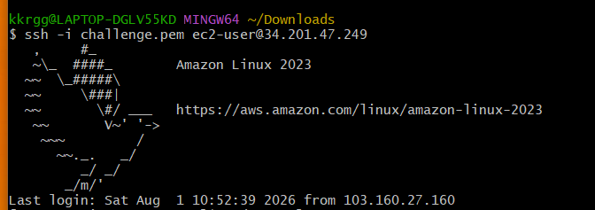

Step 2: Verify the Database
Log in to MariaDB : sudo mysql
Select the database : USE companydb;
Verify the records : SELECT * FROM employees;
Exit MariaDB : EXIT;
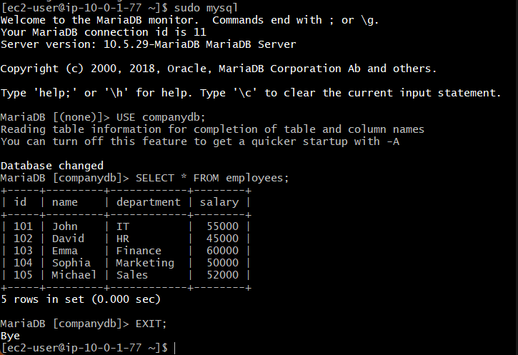

Step 3: Create the Database Backup
If using socket authentication (sudo mysql):
sudo mysqldump companydb > companydb_backup.sql
If using a root password:
mysqldump -u root -p companydb > companydb_backup.sql
Enter the password when prompted.

Step 4: Verify the Backup File
List the backup file.
ls -lh
Example Output:
-rw-r--r-- 1 ec2-user ec2-user 3.5K Aug 01 15:20 companydb_backup.sql
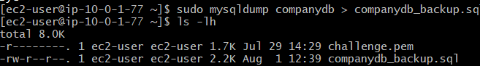

Step 5: View the Backup File
Display the beginning of the backup file.
head companydb_backup.sql
Example Output:
-- MariaDB dump
CREATE TABLE employees (
...
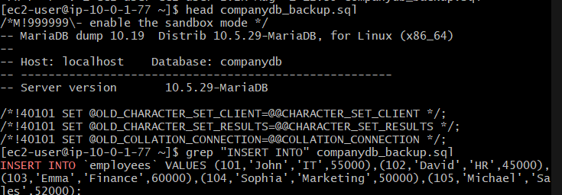
Display the end of the backup file.
tail companydb_backup.sql
You should see SQL INSERT statements or completion comments.
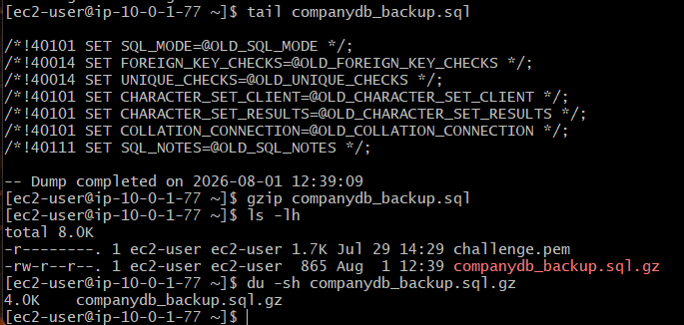

Verification
Verify the following:
- mysqldump completed successfully.
- companydb_backup.sql file exists.
- Backup file contains SQL statements.

Real-Time Use Case
A company performs a daily backup of its production database before applying application updates or migrating to Amazon RDS. If any issue occurs during the migration or upgrade, the SQL backup can be restored to recover the database quickly.

Outcome
You have successfully:
- Verified the database and its contents.
- Created a logical backup using mysqldump.
- Stored the backup as companydb_backup.sql.
- Verified the backup file.

Task 4: Launch Amazon RDS MariaDB Instance

Objective
Create an Amazon RDS MariaDB instance to host the database in a fully managed environment. The RDS instance will later be used to migrate the MariaDB database from the EC2 instance.

Prerequisites
- AWS Account
- Existing VPC
- At least two subnets in different Availability Zones (DB Subnet Group)
- Running EC2 instance
- Security Group allowing MySQL/Aurora (TCP 3306)
- MariaDB database backup (companydb_backup.sql) created on EC2

Outcome
- Amazon RDS MariaDB instance created successfully.
- Database endpoint generated.
- Security Group configured.
- EC2 instance can connect to the RDS instance.
- Ready for database migration.

What is Amazon RDS?
Amazon Relational Database Service (Amazon RDS) is a managed database service provided by AWS.
Instead of installing and managing a database on an EC2 instance, AWS manages:
- Hardware
- Operating System
- Database installation
- Software patching
- Automatic backups
- Monitoring
- High Availability
- Failover
You only manage the database and your application.

Architecture
Internet
|
SSH (22)
|
EC2 Instance
MariaDB Backup
|
MySQL Client (3306)
|
▼
Amazon RDS MariaDB Instance

Implementation Steps

Step 1: Open the Amazon RDS Console
- Log in to the AWS Management Console.
- Navigate to RDS.
- In the left navigation pane, click Databases.
- Click Create database.
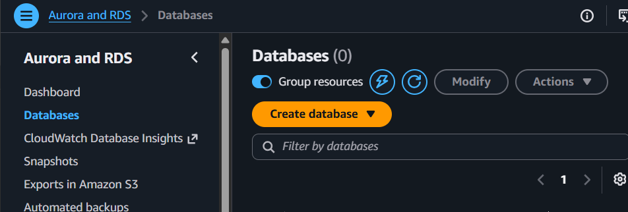

Step 2: Choose Database Creation Method
Select:
- Full configure
Click Next.

Step 3: Select Database Engine
Choose:
- Engine Type: MariaDB
Choose the latest available version (or leave the default).
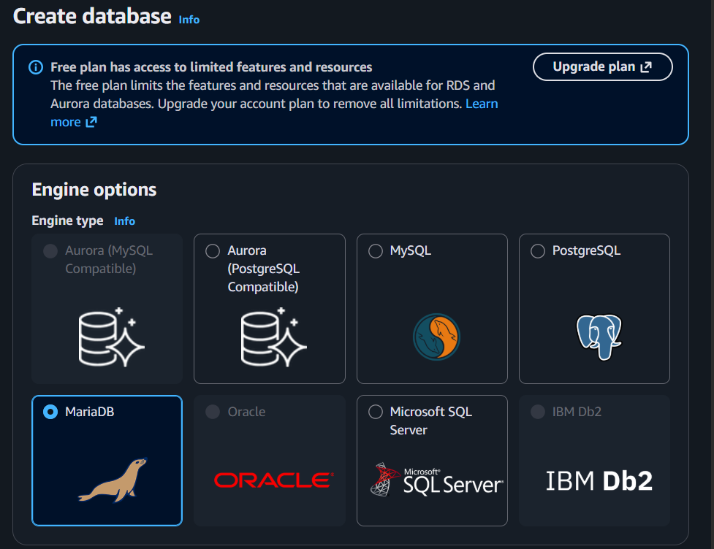

Step 4: Choose a Template
For this lab, select:
- Free Tier (if available)
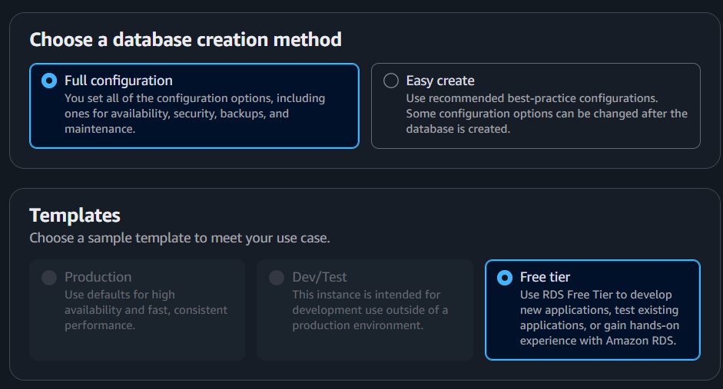

Step 5: Configure Database Settings
Enter the following values (example):
Setting | Value
DB Instance Identifier | mariadb-rds
Master Username | admin
Master Password | Create your own password
Confirm Password | Same password
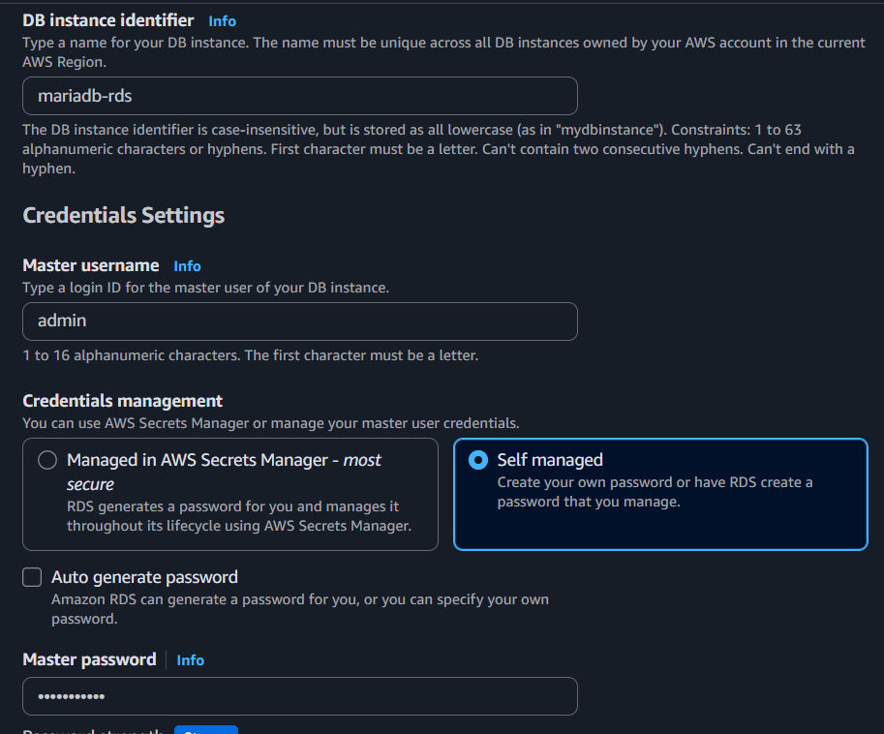

Step 6: Configure Instance
Choose:
Setting | Value
DB Instance Class | db.t3.micro (or Free Tier eligible)
Storage Type | General Purpose SSD (gp3)
Allocated Storage | 20 GB
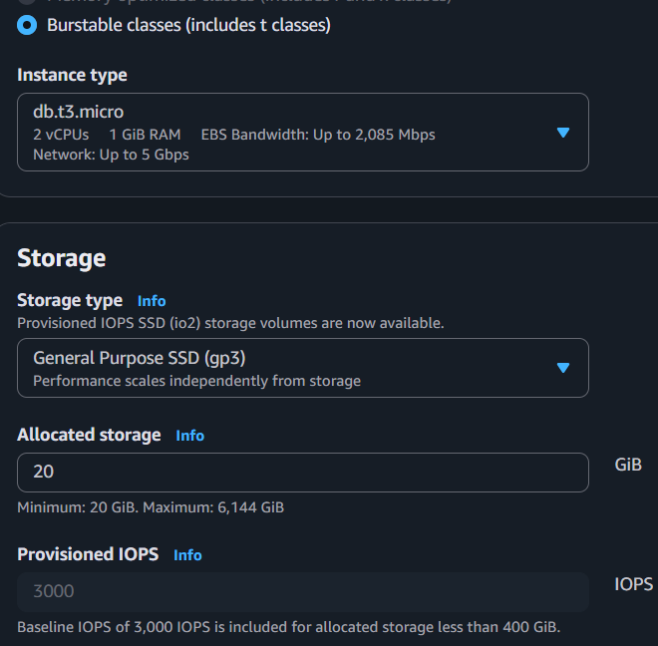

Step 7: Configure Connectivity
Select:
Setting | Value
VPC | Your existing VPC
DB Subnet Group | Default (or your custom DB subnet group)
Public Access | No (Recommended)
VPC Security Group | Create new or choose existing
Availability Zone | No Preference

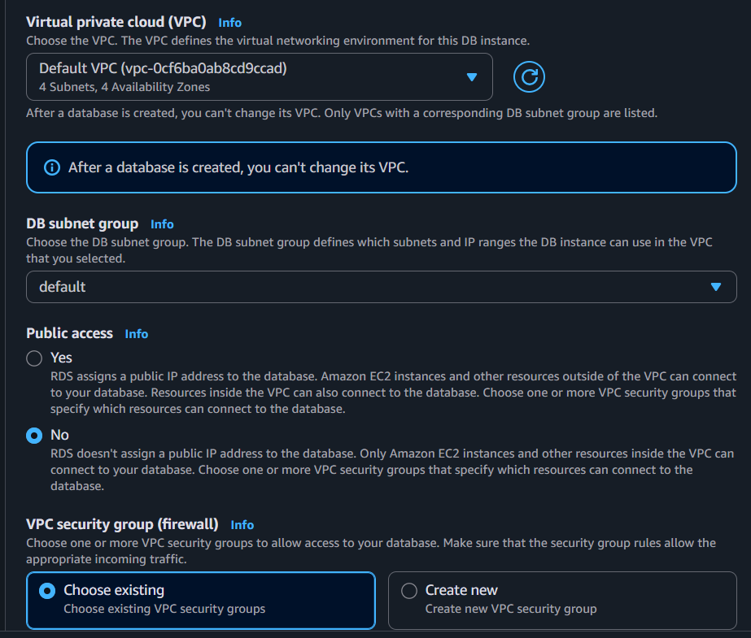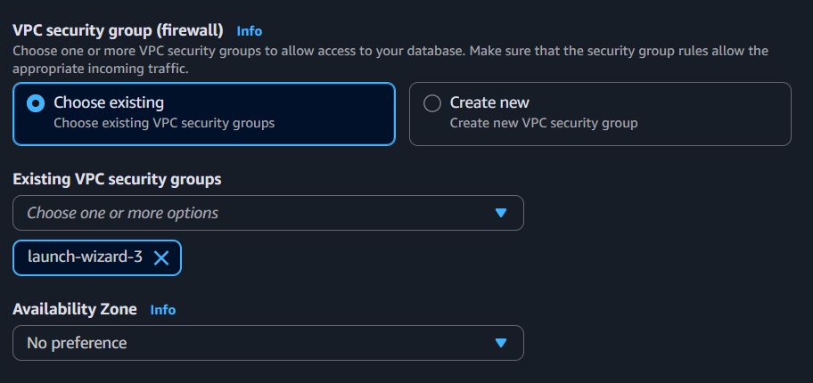

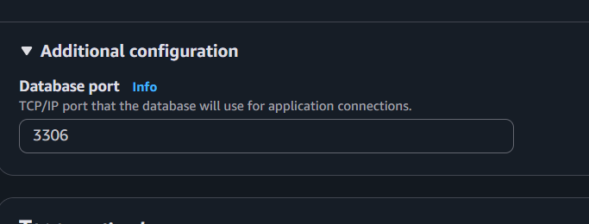

Step 8: Configure Security Group
The RDS Security Group must allow MySQL/Aurora (TCP 3306) from your EC2 instance.
Example Inbound Rule:
Type | Protocol | Port | Source
MySQL/Aurora | TCP | 3306 | EC2 Security Group (Recommended)
Note: Using the EC2 Security Group as the source is more secure than allowing 0.0.0.0/0.
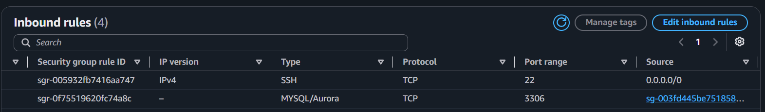

Step 9: Additional Configuration
Configure the following:
Setting | Value
Initial Database Name | Leave blank (we will create it during migration)
Automated Backups | Enabled (Default)
Backup Retention | 7 Days
Encryption | Disabled (Lab) or Enabled (Production)

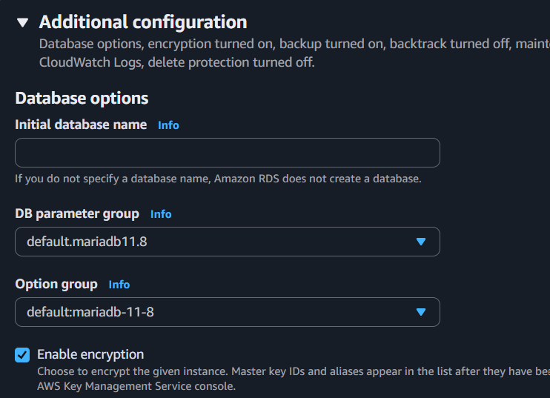

Step 10: Create the Database
Review all settings and click:
Create Database
AWS will begin provisioning the RDS instance.
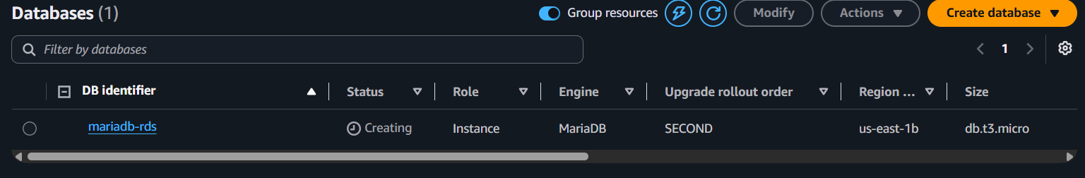

Step 11: Wait for the Instance
The database status will change:
Creating
↓
Backing-up
↓
Available
Wait until the status becomes:
Available
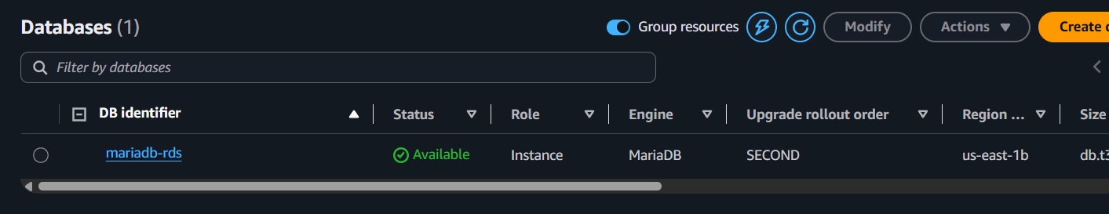

Step 12: Copy the Endpoint
After the database becomes available:
- Click the RDS instance.
- Under Connectivity & Security, copy the Endpoint.
Example:
mariadb-rds.c7abcdefg123.us-east-1.rds.amazonaws.com
You will use this endpoint in the next task to connect from the EC2 instance.
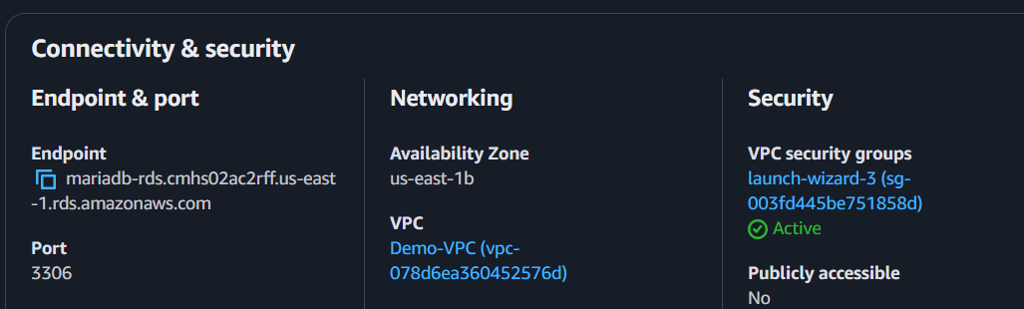

Step 13: Test Connectivity from EC2
Install the MariaDB/MySQL client if not already installed.
sudo dnf install mariadb105 -y
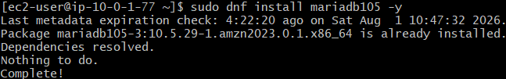
Connect to the RDS instance:
mysql -h <RDS-Endpoint> -u admin -p
Enter the password when prompted.
If the connection is successful, you will see:
Welcome to the MariaDB monitor.
MariaDB [(none)]>
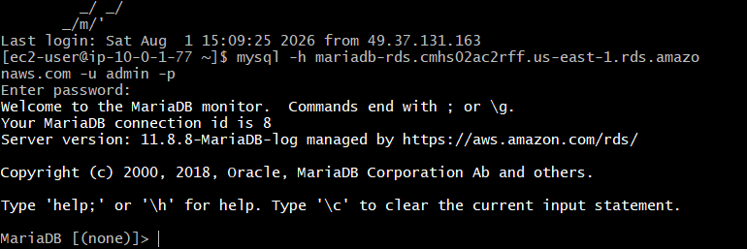

Verification
Verify the following:
- RDS instance status is Available.
- Endpoint is generated.
- Security Group allows port 3306 from the EC2 Security Group.
- Successfully connected to the RDS instance from EC2.

Real-Time Use Case
A company initially hosts its database on an EC2 instance for development. As the application grows, they migrate the database to Amazon RDS to reduce operational overhead, improve availability, enable automated backups, and simplify maintenance.

Outcome
You have successfully:
- Created an Amazon RDS MariaDB instance.
- Configured networking and security.
- Obtained the RDS endpoint.
- Verified connectivity from the EC2 instance.

Task 5: Migrate Database from EC2 to Amazon RDS MariaDB

Objective
Migrate the MariaDB database from the EC2 instance to the Amazon RDS MariaDB instance by importing the backup (companydb_backup.sql) created in Task 3.

Prerequisites
- Amazon EC2 instance is running.
- MariaDB database backup (companydb_backup.sql) exists on the EC2 instance.
- Amazon RDS MariaDB instance is in the Available state.
- RDS Security Group allows MySQL/Aurora (TCP 3306) access from the EC2 instance.
- MySQL/MariaDB client is installed on the EC2 instance.
- You can connect successfully to the RDS instance.

Outcome
- Database migrated successfully from EC2 to Amazon RDS.
- Tables and records imported successfully.
- Data verified on the RDS instance.
- Amazon RDS is ready for application use.

Architecture
EC2 Instance
│
│ companydb_backup.sql
│
▼
MySQL/MariaDB Client
│
│ Port 3306
▼
Amazon RDS MariaDB

Implementation Steps

Step 1: Verify the Backup File
On the EC2 instance, confirm that the SQL backup exists.
ls -lh
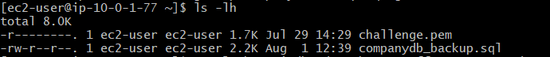

Step 2: Connect to the Amazon RDS Instance
From the EC2 instance, connect to the RDS MariaDB database.
mysql -h <RDS-Endpoint> -u admin -p
Enter the master password.
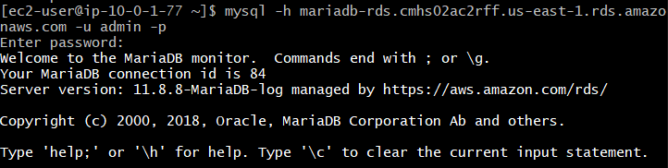

Step 3: Create the Target Database
Once connected, create a new database.
CREATE DATABASE companydb;
Verify:
SHOW DATABASES;
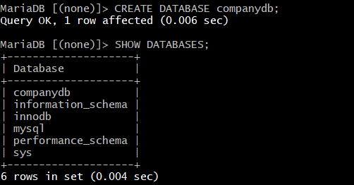
Exit MariaDB : EXIT;

Step 4: Import the Backup File
Run the following command from the EC2 instance.
mysql -h <RDS-Endpoint> -u admin -p companydb < companydb_backup.sql
Enter the password when prompted.
If the import is successful, the command returns to the prompt without displaying any output.

Step 5: Connect to the RDS Database Again
mysql -h <RDS-Endpoint> -u admin -p
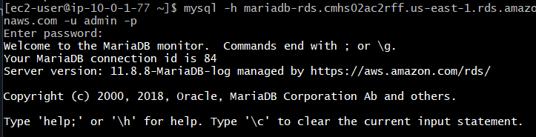
Select the database.
USE companydb;
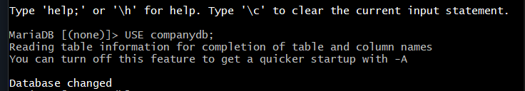

Step 6: Verify the Tables
SHOW TABLES;
Expected Output:
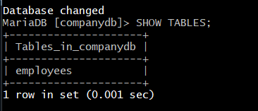

Step 7: Verify the Data
Display all records.
SELECT * FROM employees;
Expected Output:
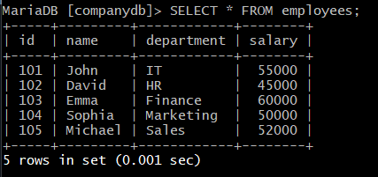

Step 8: Verify the Number of Records
SELECT COUNT(*) FROM employees;
Expected Output:
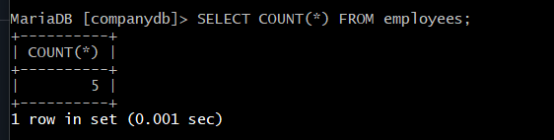

Verification
Verify the following:
- Successfully connected to the RDS instance.
- Database companydb created.
- Backup imported successfully.
- employees table exists.
- All records are available in the RDS database.
- Record count matches the source database.

Real-Time Use Case
A company initially hosts its application database on an EC2 instance. To reduce operational overhead and improve availability, the database is migrated to Amazon RDS using a mysqldump backup. After migration, applications connect to the RDS endpoint instead of the local EC2 database, benefiting from automated backups, monitoring, and high availability.

Outcome
You have successfully:
- Connected to the Amazon RDS MariaDB instance.
- Created the target database.
- Imported the SQL backup from the EC2 instance.
- Verified that all tables and data were migrated successfully.
- Prepared the Amazon RDS database for production use.

Task 6: Install MySQL on EC2

Objective
Install the MySQL client (or MySQL server, if required) on an Amazon EC2 instance. The MySQL client will be used to connect to and manage Amazon RDS MySQL databases.
Since we already have MariaDB Server installed on the EC2 instance for Tasks 1–5, we only need the MySQL client to connect to the RDS MySQL instance. Installing another MySQL server on the same EC2 instance is generally not recommended due to potential port conflicts.

Prerequisites
- AWS Account
- Running Amazon EC2 instance (Amazon Linux 2 or Amazon Linux 2023)
- Internet connectivity
- Sudo privileges
- Security Group allowing SSH (22)

Outcome
- MySQL client installed successfully.
- MySQL client version verified.
- EC2 instance ready to connect to Amazon RDS MySQL.

What is MySQL?
MySQL is an open-source Relational Database Management System (RDBMS) used to store and manage structured data. It is widely used by web applications and enterprise systems.
Unlike MariaDB, which is a community-developed fork of MySQL, Amazon RDS MySQL is the official MySQL database engine managed by AWS.

Implementation Steps

Step 1: Connect to the EC2 Instance
ssh -i challenge.pem ec2-user@<EC2-Public-IP>

Step 2: Update System Packages
Amazon Linux 2023
sudo dnf update -y
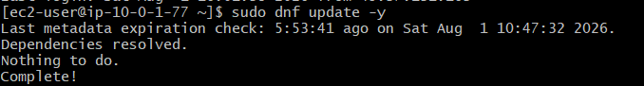

Step 3: Check Whether MySQL Client is Already Installed
mysql --version
If the command returns a version, the client is already installed.

Step 4: Install the MySQL Client (If Not Installed)
Amazon Linux 2023
sudo dnf install mariadb105 -y

Step 5: Verify the Installation
mysql –version

Step 6: Verify the Client
Display the client help page.
mysql –help
It serves three main purposes:

Verify the MySQL Client is Working
View Available Command-Line Options
Troubleshooting
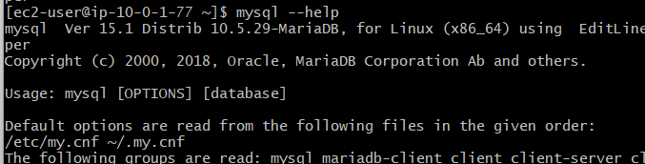

Step 7: Test the Client
Connect to the local MariaDB server.
sudo mysql
If the connection is successful, you should see:
Welcome to the MariaDB monitor.

MariaDB [(none)]>
Exit the database.
EXIT;
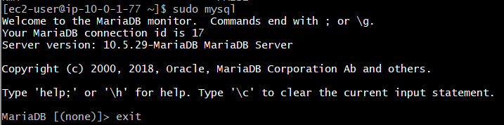

Verification
Verify the following:
- MySQL client installed successfully.
- mysql --version displays the installed version.
- mysql --help displays available options.
- Local database connection works successfully.

Real-Time Use Case
A DevOps engineer installs the MySQL client on an EC2 instance to connect securely to Amazon RDS databases. The client is used for database administration tasks such as creating databases, running SQL queries, importing backups, exporting data, and monitoring database health.

Outcome
You have successfully:
- Installed the MySQL client on the EC2 instance.
- Verified the installation.
- Confirmed the client is functioning correctly.
- Prepared the EC2 instance to connect to Amazon RDS MySQL in the next task.

Task 7: Launch Amazon RDS MySQL Image

Objective
Create an Amazon RDS MySQL instance to host a fully managed MySQL database. This instance will be used to demonstrate database management, Multi-AZ deployment, automated backups, snapshot restoration, and Read Replica creation.

Prerequisites
- AWS Account
- Existing VPC
- DB Subnet Group
- Running EC2 instance
- MySQL client installed on EC2
- Security Group allowing MySQL/Aurora (TCP 3306)
- IAM permissions to create RDS resources

Outcome
- Amazon RDS MySQL instance created successfully.
- Database endpoint generated.
- Security Group configured.
- EC2 instance successfully connected to the MySQL RDS instance.
- Ready for Multi-AZ, Backup, Restore, and Read Replica configuration.

What is Amazon RDS MySQL?
Amazon RDS MySQL is a fully managed relational database service that runs the MySQL database engine.
AWS manages:
- Database installation
- Operating System
- Software updates
- Automatic backups
- Monitoring
- High Availability
- Failover
- Hardware maintenance
You only manage:
- Databases
- Tables
- Users
- Data

Architecture
Internet
|
SSH (22)
|
EC2 Instance
MySQL Client
|
MySQL Port 3306
|
▼
Amazon RDS MySQL

Implementation Steps

Step 1: Open Amazon RDS Console
- Login to AWS Console.
- Search for RDS.
- Click Amazon RDS.
- Select Databases.
- Click Create database.

Step 2: Choose Database Creation Method
Select:
Full Configure
Click Next.

Step 3: Select Engine
Choose:
Setting | Value
Engine Type | MySQL
Engine Version | Latest available (or default)

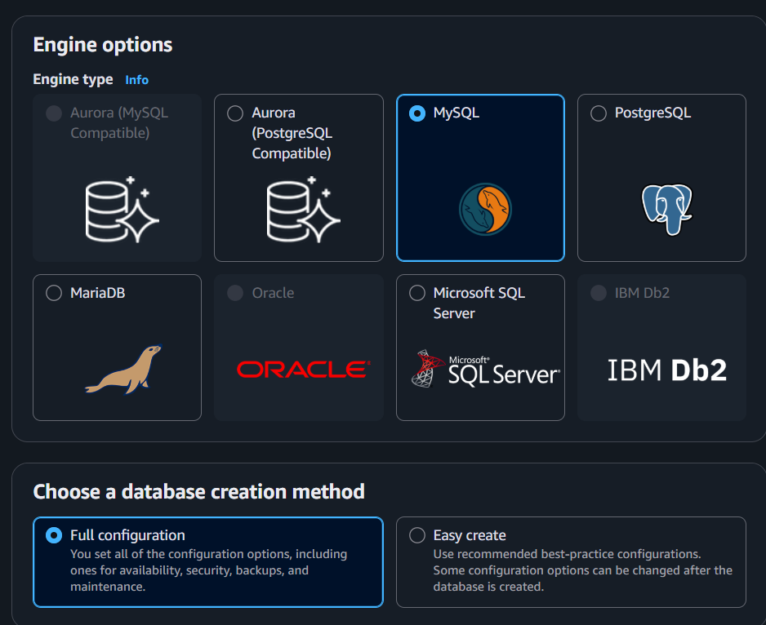

Step 4: Select Template
Choose:
Free Tier
(if available)

Step 5: Configure Database Settings
Example configuration:
Setting | Value
DB Instance Identifier | mysql-rds
Master Username | admin
Master Password | Create your own password
Confirm Password | Same password
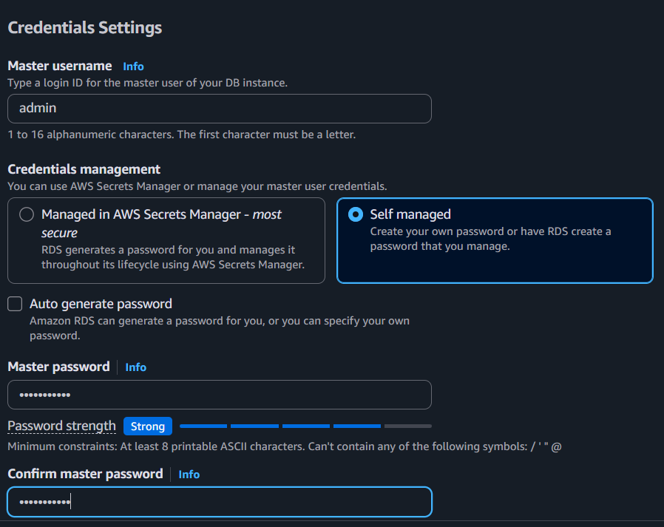

Step 6: Configure Instance
Choose:
Setting | Value
DB Instance Class | db.t3.micro or db.t4g.micro (smallest available)
Storage Type | General Purpose SSD (gp3)
Allocated Storage | 20 GB
Leave the remaining settings as default.
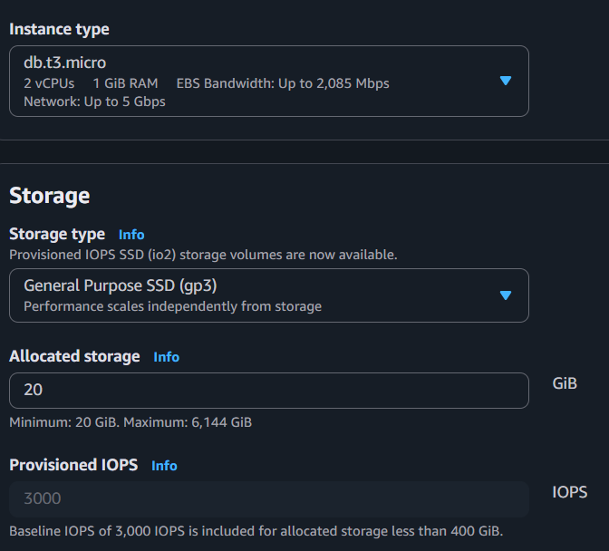

Step 7: Configure Connectivity
Setting | Value
VPC | Your existing VPC
DB Subnet Group | Create new DB Subnet Group (or existing one)
Public Access | Yes (Lab) / No (Production)
Availability Zone | No Preference
Database Port | 3306

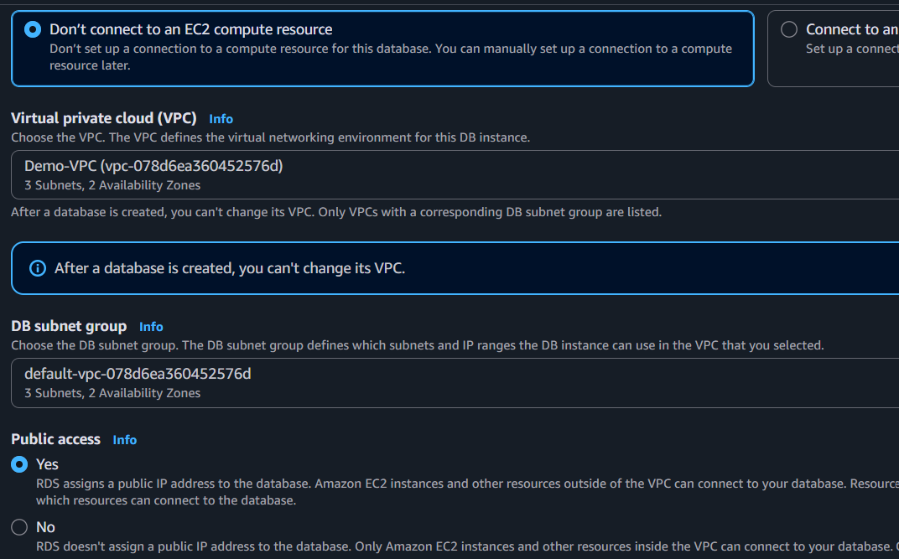

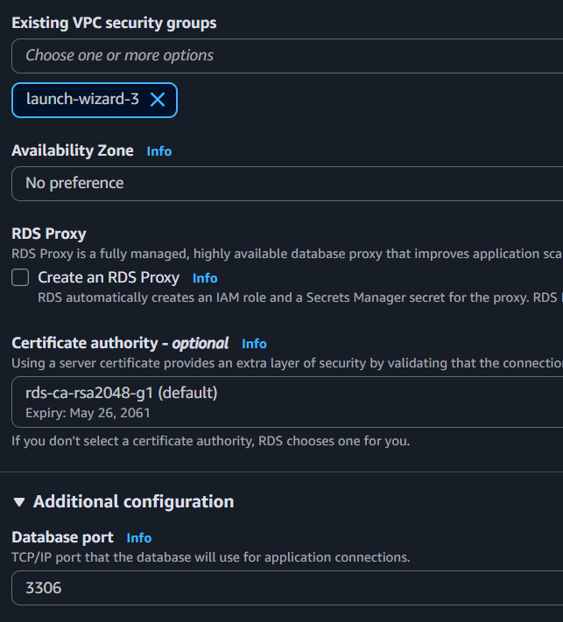
Step 8: Configure Security Group
Create New Security Group
Inbound Rule:
Type | Port | Source
MySQL/Aurora | 3306 | EC2 Security Group

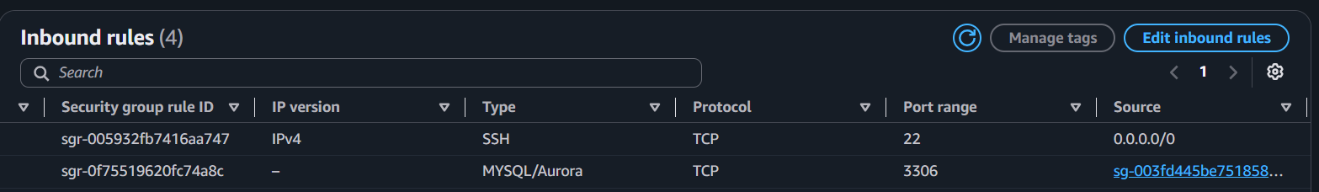

Step 9: Additional Configuration
Configure:
Setting | Value
Initial Database Name | Leave Blank
Automated Backups | Enabled
Backup Retention | 1 Day (or maximum allowed by your account)
Encryption | Disabled
Leave the remaining settings as default.
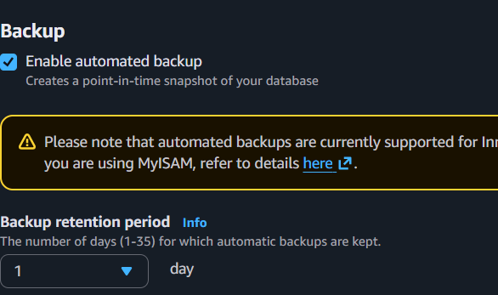

Step 10: Create Database
Click:
Create Database
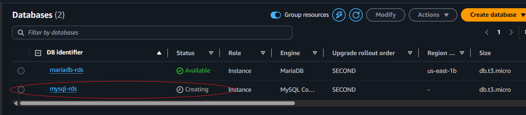
AWS starts creating the RDS instance.
Status changes:
Creating
↓
Backing-up
↓
Available
Wait until the status becomes:
Available
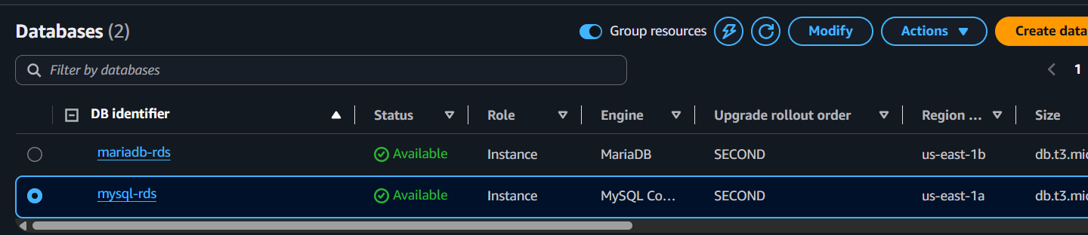

Step 11: Copy the Endpoint
Select the database.
Go to:
Connectivity & Security
Copy the Endpoint.
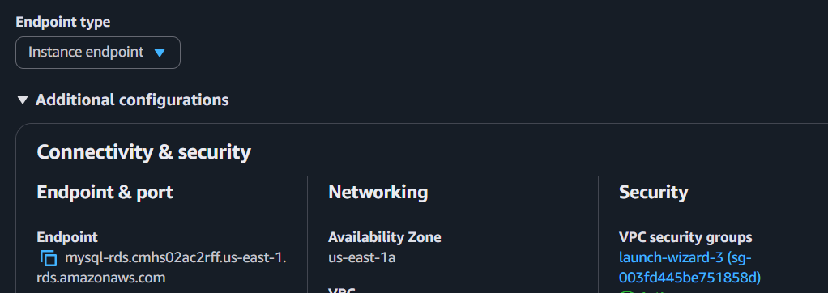

Step 12: Verify MySQL Client on EC2
Check if the MySQL client is installed.
mysql --version

Step 13: Connect to the MySQL RDS Instance
From the EC2 instance:
mysql -h <RDS-Endpoint> -u admin -p
Enter the password.
If the connection is successful, you should see:
Welcome to the MySQL monitor.

mysql>
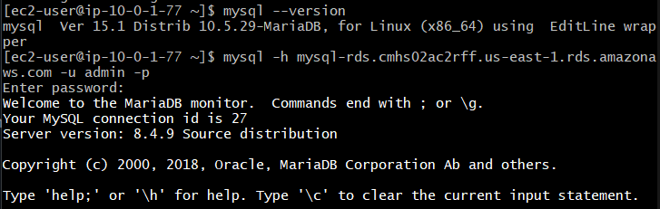

Step 14: Create a Sample Database
CREATE DATABASE companydb;
Verify:
SHOW DATABASES;
Expected Output:
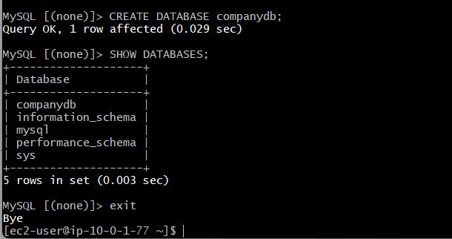

Step 15: Exit MySQL
EXIT;

Verification
Verify the following:
- RDS MySQL instance status is Available.
- Endpoint generated successfully.
- Security Group allows MySQL/Aurora (3306).
- Successfully connected from the EC2 instance.

companydb database created successfully.
Real-Time Use Case
A company migrates its on-premises MySQL database to Amazon RDS MySQL to reduce administrative effort, improve availability, and take advantage of AWS-managed backups, monitoring, and scaling. The application servers running on EC2 connect securely to the RDS endpoint for all database operations.

Outcome
You have successfully:
- Created an Amazon RDS MySQL instance.
- Configured networking and security.
- Connected from an EC2 instance using the MySQL client.
- Created a sample database.

Task 8: Configure Multi-AZ Deployment for Amazon RDS MySQL

Objective
Configure the Amazon RDS MySQL instance with a Multi-AZ deployment to improve database availability, reliability, and fault tolerance. In a Multi-AZ setup, AWS automatically creates a synchronous standby database in another Availability Zone and performs automatic failover during failures.

Prerequisites
- AWS Account
- Running Amazon RDS MySQL instance
- Two Availability Zones available in the selected AWS Region
- Appropriate IAM permissions to modify RDS instances
- Backup retention enabled (minimum 1 day)

Outcome
- Multi-AZ deployment enabled.
- Standby database created in a different Availability Zone.
- Automatic failover configured.
- Database remains available during AZ failures or maintenance events.

What is Multi-AZ?
Multi-AZ (Multiple Availability Zones) is a high-availability feature of Amazon RDS.
When enabled:
- AWS creates a Primary DB Instance in one Availability Zone.
- AWS creates a Standby DB Instance in another Availability Zone.
- Data is synchronously replicated from the primary to the standby.
- Applications always connect to the same RDS endpoint.
- If the primary fails, AWS automatically switches to the standby.

Why Use Multi-AZ?
- High Availability
- Automatic Failover
- Disaster Recovery
- Planned Maintenance with minimal downtime
- Improved Business Continuity

Architecture
Application
│
│
RDS Endpoint
│
┌───────────┴───────────┐
│ │
Primary DB Standby DB
Availability Zone A Availability Zone B
│ │
└────── Synchronous Replication ──────┘

Implementation Steps

Step 1: Open Amazon RDS Console
- Login to AWS Console.
- Search for RDS.
- Click Amazon RDS.
- Click Databases.

Step 2: Select the MySQL RDS Instance
Select your MySQL database instance.
Example:
mysql-rds

Step 3: Modify the Database
Click:
Modify

Step 4: Enable Multi-AZ
Scroll to the Availability & Durability section.
Locate:
Multi-AZ deployment
Select:
Create a standby instance (Multi-AZ)

Step 5: Apply Changes
Scroll to the bottom.
Choose:
Apply Immediately
Click:
Modify DB Instance

Step 6: Wait for the Modification
The instance status changes:
Modifying
↓
Backing-up
↓
Available
This process may take 10–20 minutes, depending on the instance size and workload.

Step 7: Verify Multi-AZ Status
After the instance status becomes Available:
- Open the RDS instance.
- Go to the Configuration tab.
- Verify:
Setting | Expected Value
Multi-AZ | Yes

Step 8: Verify Availability Zone
The RDS instance details should show:
Primary AZ:
us-east-1a

Standby AZ:
us-east-1b
(The actual Availability Zones may differ.)

Step 9: Test Database Connectivity
From the EC2 instance:
mysql -h <RDS-Endpoint> -u admin -p
Enter the password.
Verify the connection:
SHOW DATABASES;
Expected output:
companydb
information_schema
mysql
performance_schema
sys

Step 10: Verify the Endpoint
Go to:
RDS → Databases → mysql-rds → Connectivity & Security
Verify that the Endpoint remains the same after enabling Multi-AZ.
Important: Applications continue using the same endpoint even if failover occurs.

Verification
Verify the following:
- Multi-AZ deployment is enabled.
- Standby instance created successfully.
- RDS instance status is Available.
- Same endpoint is used for both primary and standby.
- Database connectivity from EC2 is successful.
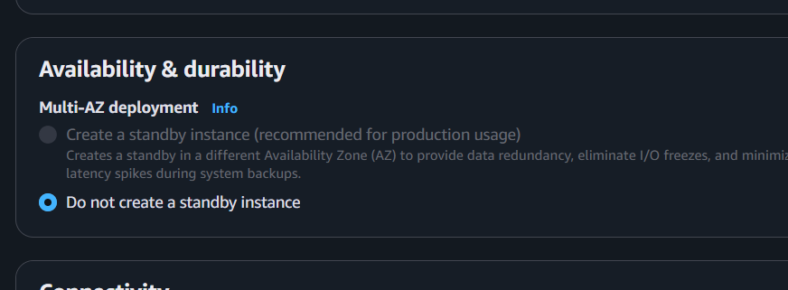
The screenshots confirm that Multi-AZ is disabled by your current AWS Free plan:
- Convert to Multi-AZ deployment is greyed out.
- Create a standby instance is greyed out.
- Only Do not create a standby instance is selectable.
This is an account-plan limitation, not a configuration error. db.t4g.micro, MySQL 8.4, the default subnet group, and the six Availability Zones are otherwise suitable.
options
Option 1: Skip Multi-AZ for this lab — recommended
Document Task 8 as:
Multi-AZ configuration could not be enabled because the AWS Free plan
restricts the standby-instance feature. The MySQL RDS instance remains
Single-AZ. Screenshots were captured as evidence.
This avoids extra charges.
Option 2: Upgrade the AWS plan
Use the Upgrade plan link displayed on the RDS creation page. After upgrading:
RDS → mysql-rds-instance → Modify
→ Availability & durability
→ Create a standby instance
→ Continue → Apply immediately
Multi-AZ creates another RDS instance and normally increases compute and storage costs.

Task 9: Take Database Backup and Restore Using Commands

Objective
Create a logical backup of the MySQL RDS database using mysqldump, store it in a backup directory on the EC2 instance, and restore the database from the backup file using MySQL commands.

Prerequisites
- Running Amazon RDS MySQL instance
- EC2 instance with MySQL client installed
- Existing database (companydb) with sample data
- Connectivity from EC2 to RDS

Outcome
- Backup directory created on EC2.
- Database backup stored as a .sql file.
- Backup verified.
- Database restored from the backup file.
- Data verified after restore.

Implementation Steps

Step 1: Connect to the EC2 Instance
ssh -i challenge.pem ec2-user@<EC2-Public-IP>

Step 2: Create a Backup Directory
mkdir -p ~/db_backups
Verify:
ls
Expected Output:
challenge.pem
companydb_backup.sql
db_backups
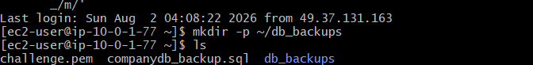

Step 3: Take a Logical Backup
mysqldump -h <RDS-ENDPOINT> -u admin -p companydb > ~/db_backups/companydb_backup.sql
Example:
mysqldump -h mysql-rds.xxxxxxxxx.us-east-1.rds.amazonaws.com -u admin -p companydb > ~/db_backups/companydb_backup.sql
Enter the RDS password when prompted.

Step 4: Verify the Backup File
Check the file:
ls -lh ~/db_backups
Example Output:
total 4.0K
-rw-r--r-- 1 ec2-user ec2-user 2.2K Aug 2 10:30 companydb_backup.sql

Step 5: Verify the Backup Contents
head -20 ~/db_backups/companydb_backup.sql
Expected Output:
-- MySQL dump
--
-- Table structure for table `employees`
Verify that the backup contains data:
grep -i "INSERT INTO" ~/db_backups/companydb_backup.sql
Expected Output:
INSERT INTO `employees` VALUES ...
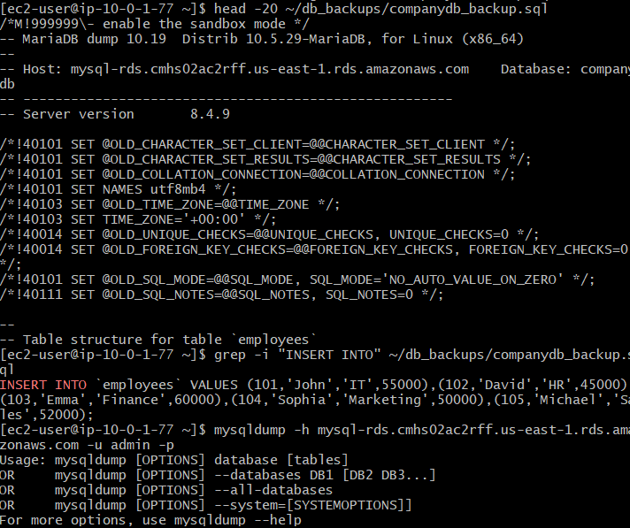

Step 6: (Optional Demo) Drop the Table
practice in a lab environment.
Connect to RDS:
mysql -h <RDS-ENDPOINT> -u admin -p
Execute:
USE companydb;

DROP TABLE employees;
Verify:
SHOW TABLES;
Expected Output:
Empty set
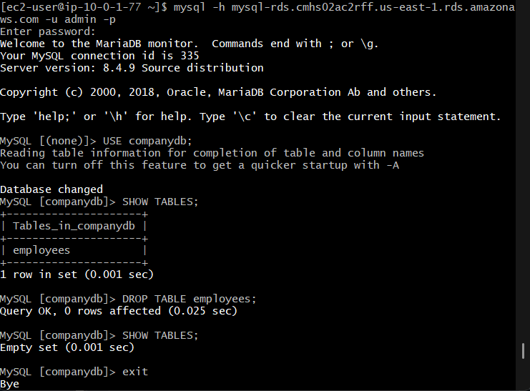

Step 7: Restore the Database
Exit MySQL:
exit;
Restore the backup:
mysql -h <RDS-ENDPOINT> -u admin -p companydb < ~/db_backups/companydb_backup.sql
Enter the password.
If successful, the command returns to the prompt without any output.
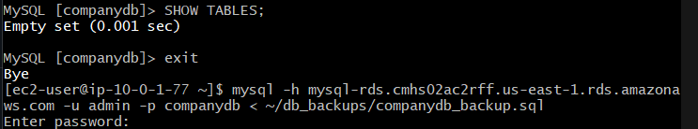

Step 8: Verify the Restore
Reconnect:
mysql -h <RDS-ENDPOINT> -u admin -p
Execute:
USE companydb;

SHOW TABLES;

SELECT * FROM employees;
Expected Output:
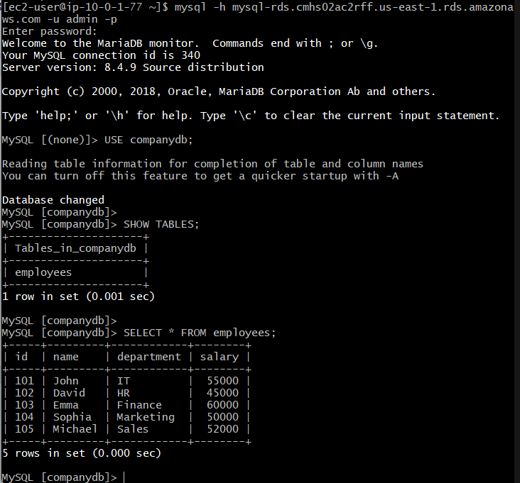
The dummy records should be displayed.

Verification
Verify the following:
- ✅ Backup directory created.
- ✅ Backup file (companydb_backup.sql) created.
- ✅ Backup contains table structure and data.
- ✅ Database restored successfully.
- ✅ Dummy data available after restore.

Real-Time Use Case
A DevOps engineer schedules a daily mysqldump backup using a cron job. The SQL backup files are stored in a dedicated backup directory and uploaded to Amazon S3. If the database becomes corrupted or data is accidentally deleted, the latest backup can be restored quickly using the MySQL client.

Outcome
- Successfully created a logical backup of the MySQL RDS database.
- Stored the backup in a dedicated directory on EC2.
- Verified the backup file.
- Restored the database using the SQL dump.
- Confirmed that the original data was recovered

Task 10: Create Read Replica

Objective
Create a Read Replica of an Amazon RDS MySQL database to improve read performance, distribute read traffic, and provide a copy of the primary database for reporting and analytics.

Prerequisites
- AWS Account
- Running Amazon RDS MySQL instance
- Backup retention period set to 1 day or more
- Source RDS instance status Available
- IAM permissions to create Read Replicas

Outcome
- Read Replica created successfully.
- Replica synchronized with the primary database.
- Read queries executed from the replica.
- Write operations allowed only on the primary database.

Implementation Steps
Step 1: After deleting one instance, Restore the RDS Instance
- Go to Amazon RDS.
- Click Snapshots.
- Select your snapshot (status should be Available).
- Click Actions → Restore Snapshot.

Step 2: Configure the Restored Instance
Use the following settings:
Setting | Value
DB Instance Identifier | mysql-rds-restored
Engine | MySQL
DB Instance Class | db.t3.micro (or the smallest available)
VPC | Your existing VPC
DB Subnet Group | Your existing DB subnet group
Public Access | Yes (for this lab)
Security Group | Existing RDS Security Group
Backup Retention | 1 day
Leave the remaining settings as default and click Restore DB Instance.
Since you have no active RDS instances now, the restore should succeed.
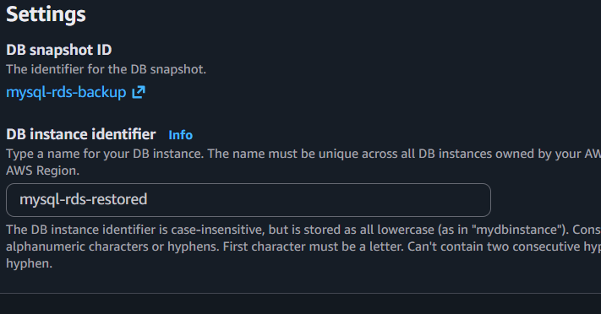
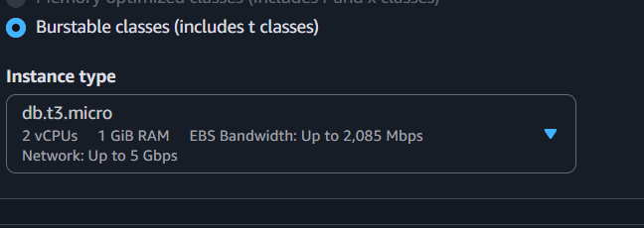
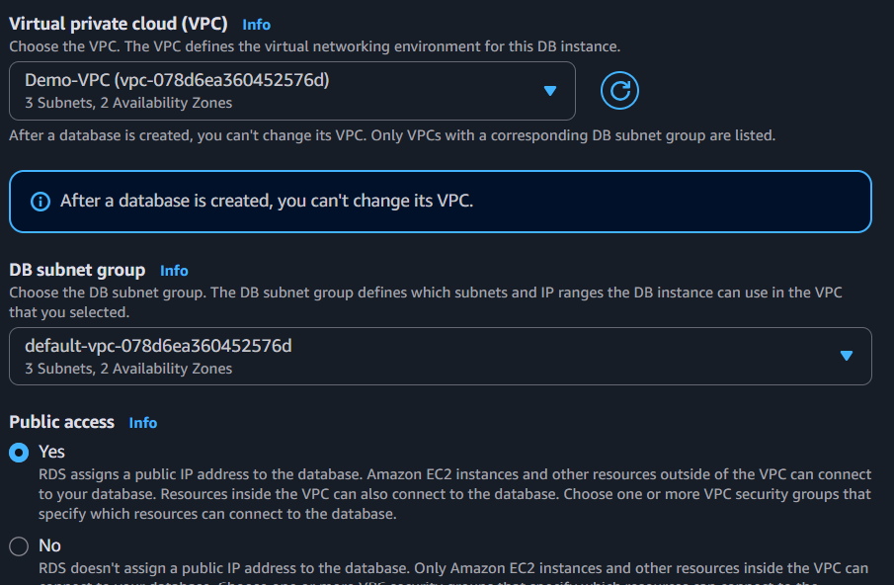
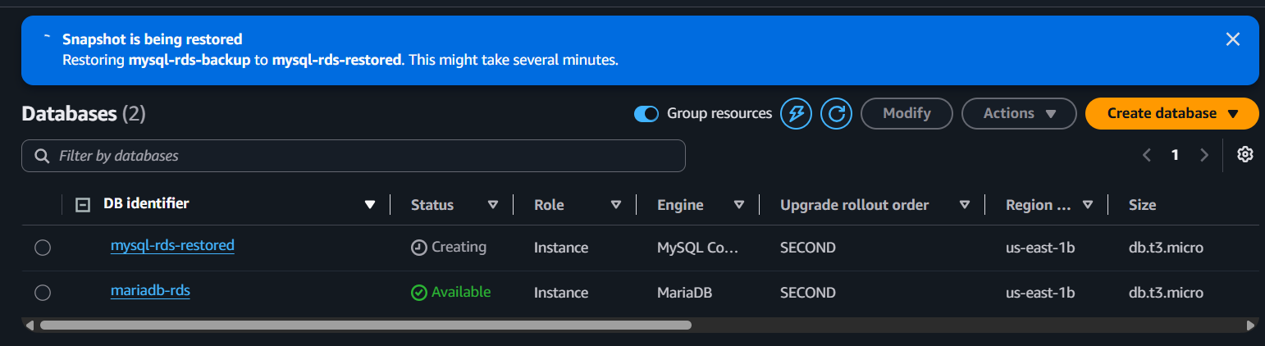

Step 3: Wait for the Status
Wait until the restored instance status becomes:
Available

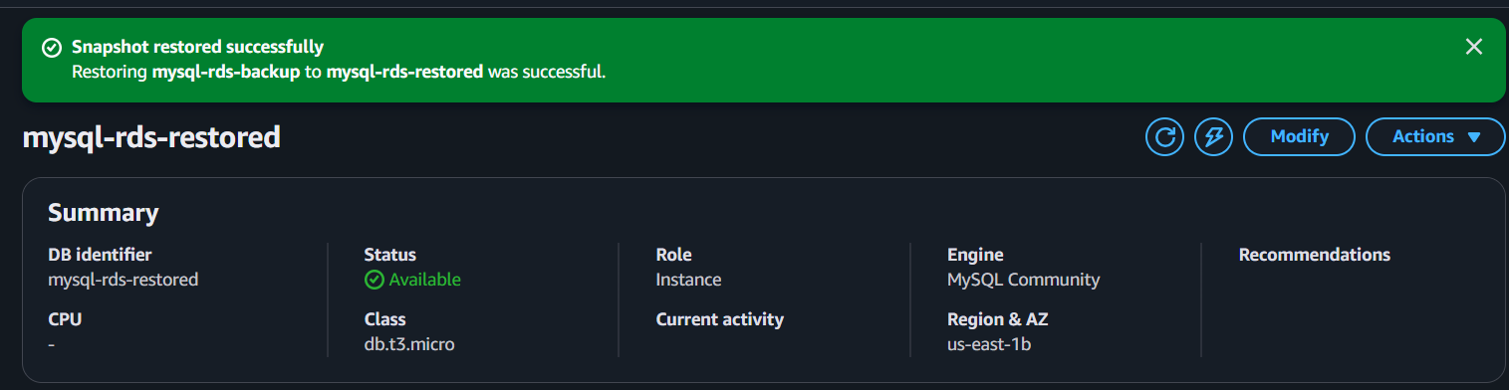

Step 4: Verify the Database
Go to:
AWS Console → Amazon RDS → Databases
Verify:
- DB Status = Available
- Backup Retention = 1 day or more

Step 5: Create the Read Replica
- Open Amazon RDS.
- Click Databases.
- Select the primary RDS instance.
- Click Actions.
- Select Create Read Replica.
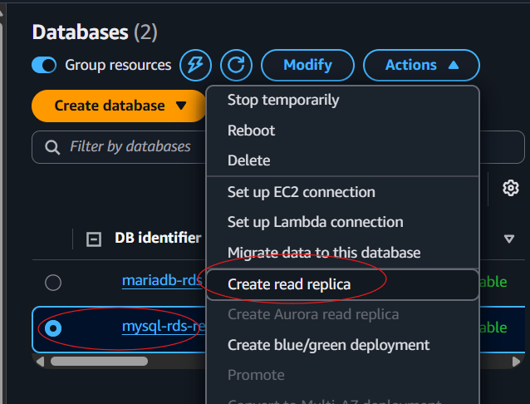

Step 6: Configure the Read Replica
Provide the following details:
Setting | Value
DB Instance Identifier | mysql-read-replica
DB Instance Class | db.t3.micro (or the smallest available)
VPC | Existing VPC
DB Subnet Group | Existing DB Subnet Group
Public Access | Yes (Lab)
Security Group | Existing RDS Security Group
Leave the remaining settings as default.
Click Create Read Replica.
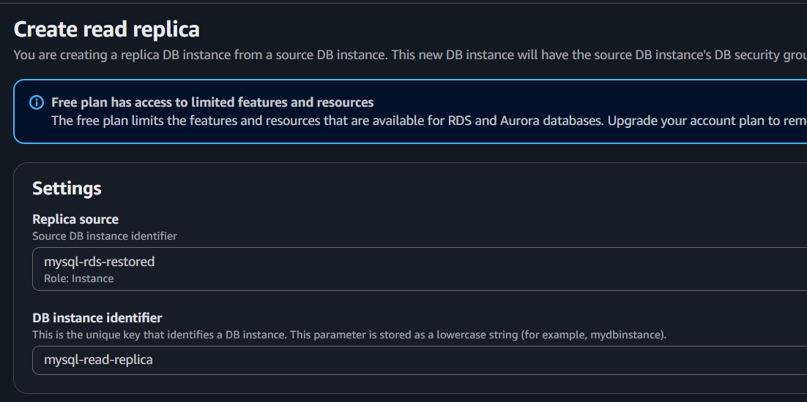
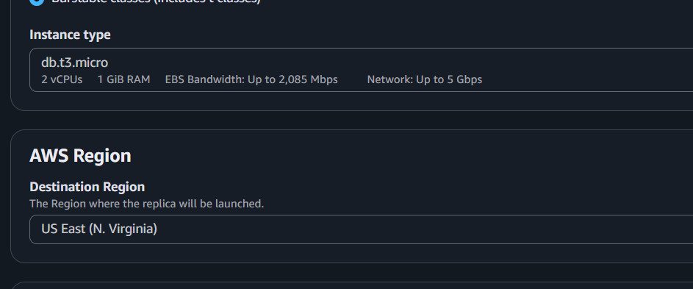
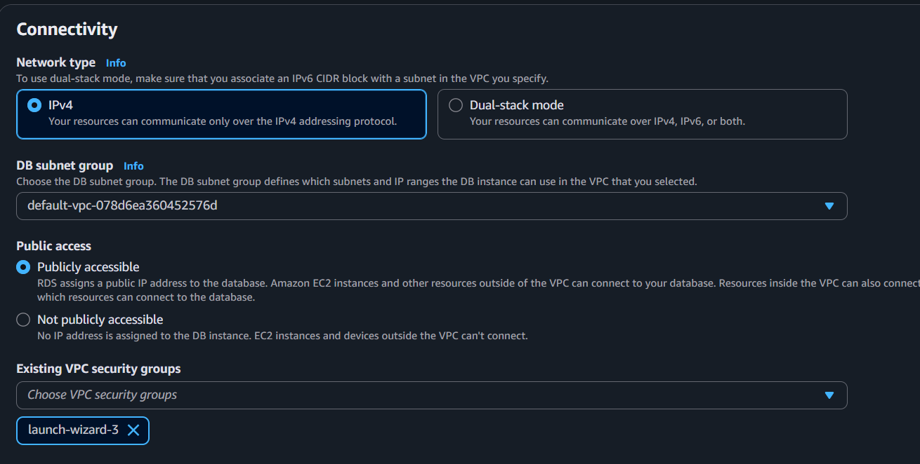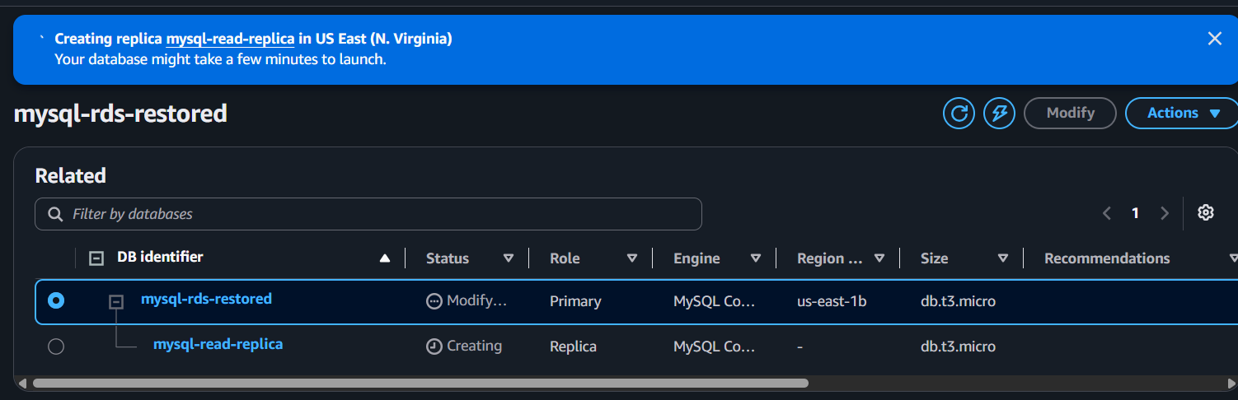

Step 7: Monitor the Replica
Go to:
RDS → Databases
The Read Replica status changes as follows:
Creating
↓
Backing up
↓
Available
Wait until the status is Available.
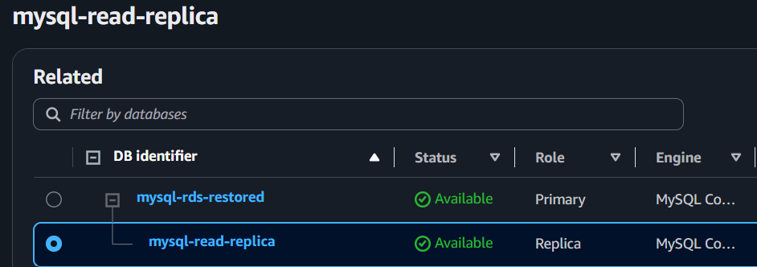

Step 8: Connect to the Read Replica
From the EC2 instance:
mysql -h <read-replica-endpoint> -u admin -p
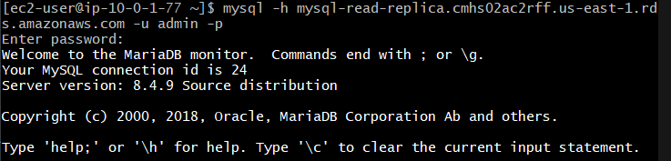
Verify the database:
SHOW DATABASES;

USE companydb;

SELECT * FROM employees;
The same data should be displayed as in the primary database.
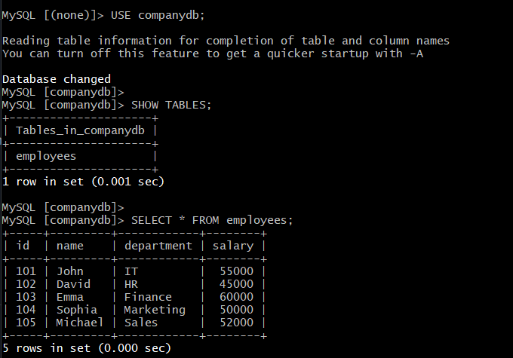

Step 9: Verify Replication

On the Primary Database
Insert a new record:
USE companydb;

INSERT INTO employees
VALUES (106,'Robert','Admin',65000);
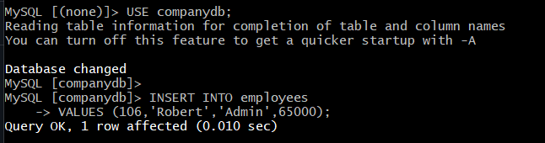

On the Read Replica
Execute:
SELECT * FROM employees;
Expected Output:
101 John
102 David
103 Emma
104 Sophia
105 Michael
106 Robert
This confirms replication is working.
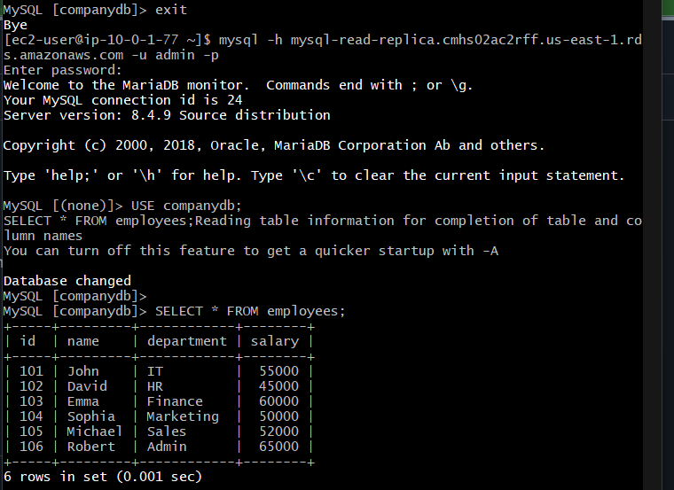

Step 10: Verify Read-Only Behavior
Try inserting data into the Read Replica:
INSERT INTO employees
VALUES (107,'Chris','IT',70000);
Expected Error:
ERROR 1290 (HY000):
The MySQL server is running with the --read-only option.
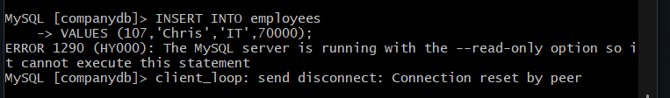
This confirms that Read Replicas are read-only.

Verification
- ✅ Read Replica status is Available.
- ✅ Data synchronized with the primary database.
- ✅ New records appear automatically after being inserted into the primary.
- ✅ Write operations are blocked on the Read Replica.

Real-Time Use Case
An e-commerce application receives thousands of customer searches every minute. To reduce the load on the primary database, all read operations (such as product searches and reports) are directed to one or more Read Replicas, while write operations (such as placing orders and updating inventory) continue to use the primary database. This improves application performance and scalability.

Outcome
- Successfully understood the process of creating a Read Replica.
- Learned how Read Replicas improve read scalability.
- Verified that data is automatically replicated from the primary database.
- Confirmed that Read Replicas are read-only

